# **Practical 12**

INDADD 2015/2016  
Introduction to Database Analysis and 柄  
School of Computing  
Week 12: SQL revision

Top of Form

## Part I:

Implement the following ERD on your MySQL server and enter all the records.

## Case study

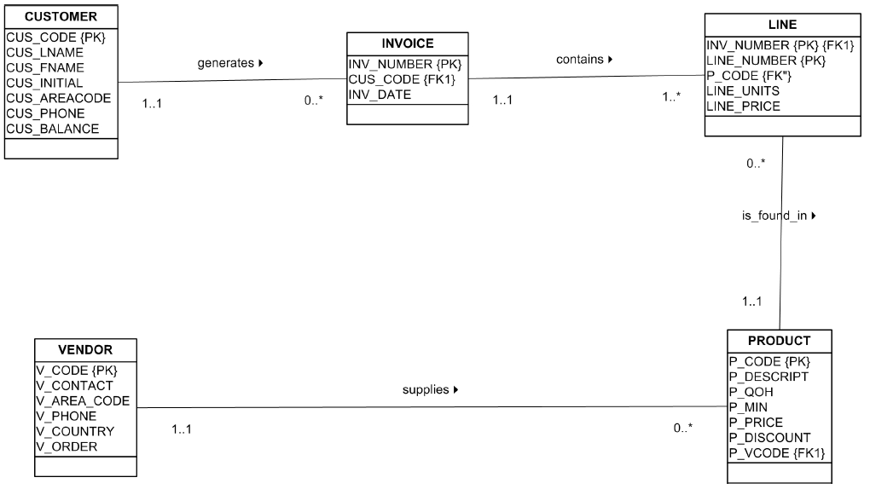

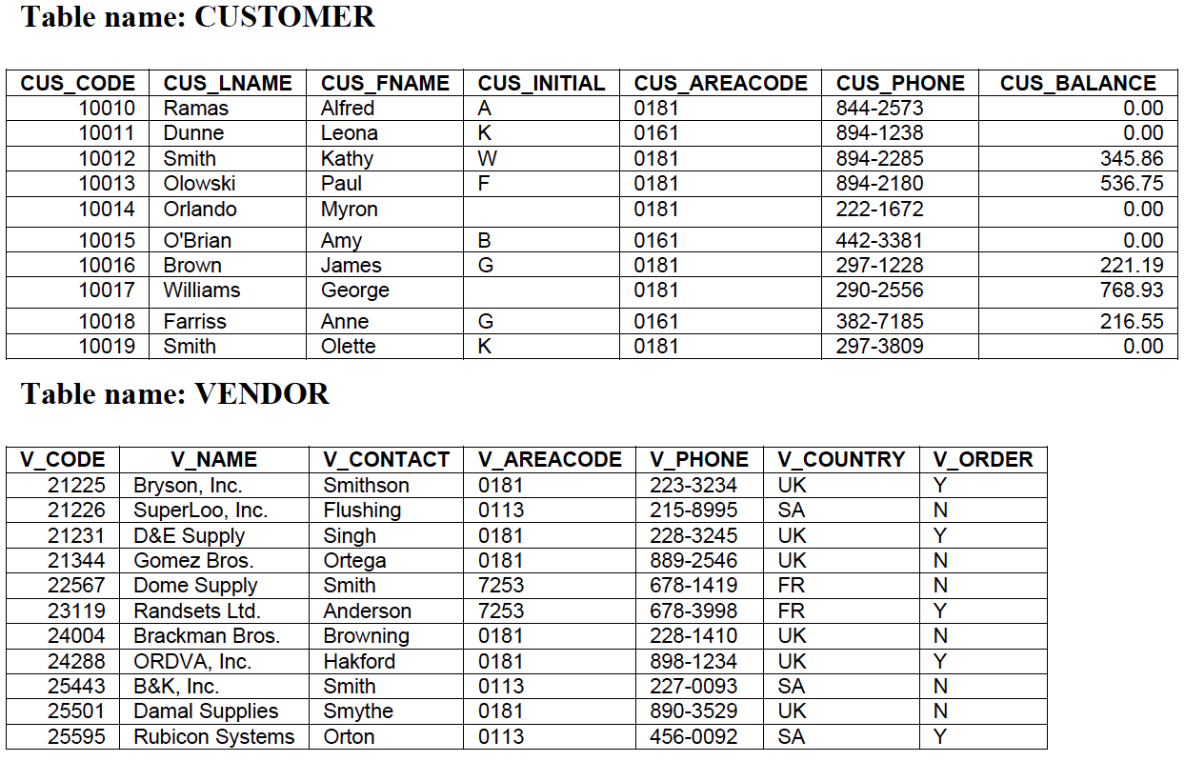

## Table name: Product

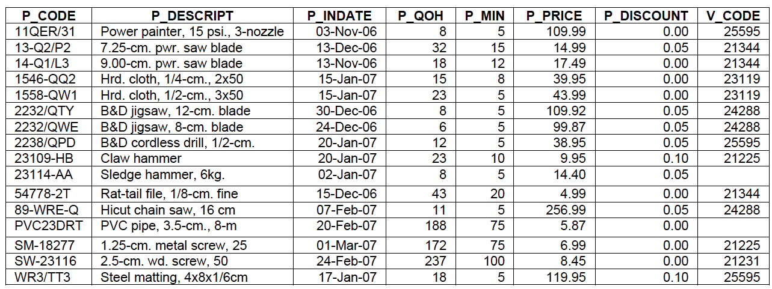

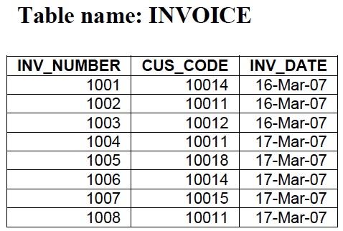

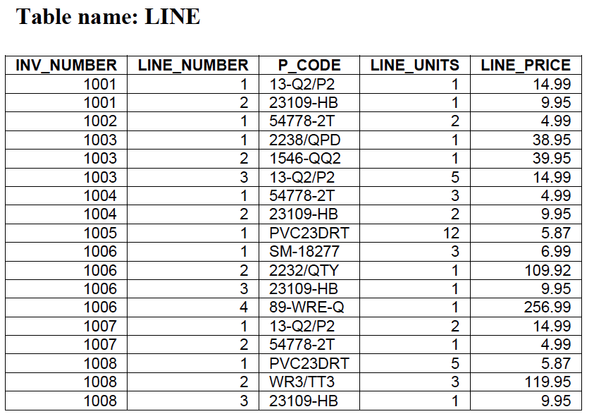

## Part II (Quiz):

Answer all the following questions, the answers will be discussed with you on next practical (1st week in the 2nd teaching block)

**1. Write query to list the CUS_CODE and CUS_LNAME for all the customers. What is the equivalent relational algebra for your SQL query?**

SELECT CUS_CODE, CUS_LNAME FROM CUSTOMER;

**2. Write query to list the CUS_CODE and CUS_LNAME for all the customers ordered by CUS_LNAME**

SELECT CUS_CODE, CUS_LNAME FROM CUSTOMER

ORDER BY CUS_LNAME;

**3. Write query to list the CUS_CODE and CUS_LNAME for all the customers with balance greater than 300 ordered by price.**

SELECT CUS_CODE, CUS_LNAME FROM CUSTOMER

GROUP BY CUS_BALANCE

HAVING CUS_BALANCE >= 300;

**4. Write query to list the P_DESCRIPTION and V_CODE for all the products in which the price is less than 50. What is the equivalent relational algebra for your SQL query?**

SELECT P_DESCRIPT, V_CODE FROM PRODUCT

WHERE P_PRICE <= 50;

**5. Write a query to list the P_DESCRIPTION and V_NAME for all the products. What is the equivalent relational algebra for your SQL query?**

SELECT P_DESCRIPT, V_NAME

FROM PRODUCT, VENDOR

WHERE PRODUCT.V_CODE = VENDOR.V_CODE;

**6. Write a query to count the number of invoices.**

SELECT COUNT(*) FROM INVOICE;

**7. Write a query to count the number of customers with a customer balance over 500.**

SELECT COUNT(*) FROM CUSTOMER

WHERE CUS_BALANCE >=500;

**8. Write a query to calculate the average price of all the products.**

SELECT AVG(P_PRICE)

FROM PRODUCT;

**10. Create a query to produce the following output.**

SELECT V_CODE, COUNT(V_CODE), AVG(P_PRICE)

FROM PRODUCT

GROUP BY V_CODE;

## Captionless Image

## Answers:

1. Write a query to list the CUS_CODE and CUS_LNAME for all the customers. What is the equivalent relational algebra for your SQL query? Select CUS_CODE, CUS_LNAME From CUSTOMER;

2. Write query to list the CUS_CODE and CUS_LNAME for all the customers ordered by CUS_LNAME Select CUS_CODE, CUS_LNAME From CUSTOMER Order By CUS_LNAME;

3. Write query to list the CUS_CODE and CUS_LNAME for all the customers with balance greater than 300 ordered by price. Select CUS_CODE, CUS_LNAME From CUSTOMER Where CUS_BALANCE > 300;

4. Write query to list the P_DESCRIPTION and V_CODE for all the products in which the price is less than 50. What is the equivalent relational algebra for your SQL query? Select P_DESCRIPTION, V_CODE From PRODUCT Where P_Price <50;

5. Write a query to list the P_DESCRIPTION and V_NAME for all the products. What is the equivalent relational algebra for your SQL query? Select Select P_DESCRIPTION, V_NAME From Product P, Vendor V Where P.V_CODE = V.V_CODE; or Select P_DESCRIPTION, V_NAME From Product P Join Vendor V On P.V_CODE = V.V_CODE;

6. Write a query to count the number of invoices. Select Count(*) From INVOICES;

7. Write a query to count the number of customers with a customer balance over 500. Select Count(*) From CUSTOMER Where CUS_BALANCE > 500;

8. Write a query to calculate the average price of all the products. Select AVG(P_PRICE) From PRODUCT;

9. Create a query to produce the total purchase per invoice, generating the results shown in the table below. The Invoice Total is the sum of the product purchases in the LINE that corresponds to the INVOICE. Select INV_NUMBER, Count(LINE_PRICE) as 'Invoice Total' From LINE Group By INV_NUMBER;

10. Create a query to produce the following output. Select V_CODE, Count(V_CODE) as 'Items count', AVG(P_PRICE) as 'Avg Price' From PRODUCT Group By V_Code